Day 1 Hunger Games, Spirit Bear, Maze Runner 3 chapters
All American Boys – Friday The Agony of Bun O’Keefe 2 chpts
57 Bus 32 pages
Discuss/ make notes with your group:

- What are the different types of groups possible in which to belong?
-Make a list! Everyone needs this in their journal.
2. Who are the characters so far? What are they like? How are they connected?
3. What kind of place is the setting?

DAY 2 Hunger Games, Spirit Bear, 3 chapters
All American Boys – Saturday The Agony of Bun O’Keefe 2 chpts
57 Bus 32 pages Maze Runner 4 chapters (7,8,9,10)

Discuss/ make notes with your group:

- What is the problem in this book? Who does it involve?
- How?

3. What groups do your characters belong to, how does it affect their life? Please write this down in your shared document.

DAY 3 Hunger Games, Spirit Bear end of chapter 9
All American Boys – Sunday The Agony of Bun O’Keefe 5,6
57 Bus 32 pages Maze Runner 11-17 including 17

DAY 3 Discuss/ make notes with your group:

- How are the characters being treated by other groups? What obstacles does your character face? How are they dealing with it/them?

- Authors tend to use 3 levels of conflict:
-Character within the character, vs another character, conflicts with something outside the character.
What do you see happening in your book discuss all 3 please?

DAY 4 Hunger Games, Spirit Bear 3 Chapters each
All American Boys – Monday The Agony of Bun O’Keefe 2 chpts
57 Complete all of Richard (Part 2) Maze Runner 18 – 24 including

Discuss/ make notes with your group:

- Read your quote aloud and discuss who it is about? What is the context?
- Discuss what quotes you can use to support the conflict in the story so far, and the development of your characters.

- Find some! (One pager after next day of reading)

Day 5 Hunger Games, Spirit Bear 3 chapters
All American Boys – Tuesday The Agony of Bun O’Keefe 2 chpts
57 Bus 32 pages Maze Runner 25 - 31

Discuss with your group:
1./ How does the P.O.V. chosen in the writing of your book affect your take on it?
2./ Do you think this perspective is intentional text structure on the part of the author? Why?
**One Pager Activity next class

Day 6 One pager Activity: Use of drawing and symbols and writing
1./ Fill in the top panes with examples of conflict: internal, vs character, vs society
2./ Then the bottom shows the characters and their changes based on the experiences so far
3./ Outside border or frame is for a quote or line to support your ideas one for each.
4./ Put the title of your novel in the center space.
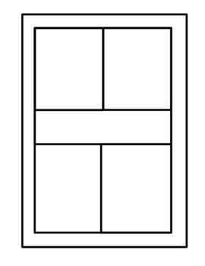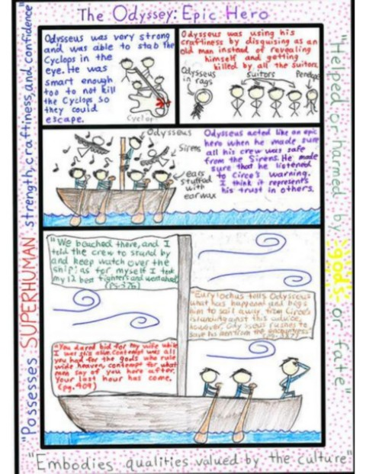

Day 7 Hunger Games, Spirit Bear 3 chapters
All American Boys – Wednesday The Agony of Bun O’Keefe 2 chpts
57 Bus 32 pages Maze Runner 32-36

